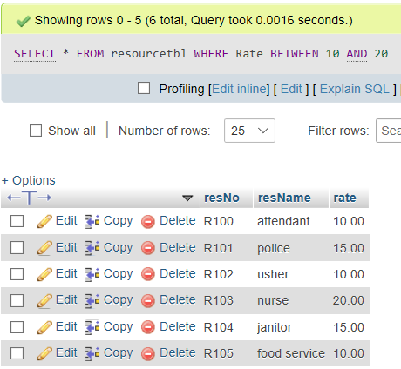

SELECT \* FROM resourcetbl WHERE Rate BETWEEN 10 AND 20